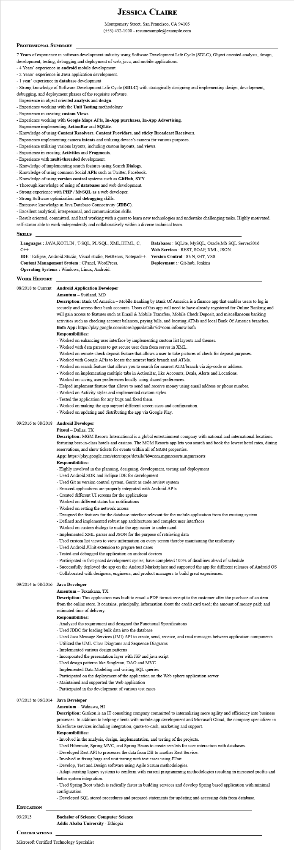
JESSICA CLAIRE
Montgomery Street, San Francisco, CA 94105
(555) 432-1000 - resumesample@example.com
PROFESSIONAL SUMMARY
7 Years of experience in software development industry using Software Development Life Cycle (SDLC), Object oriented analysis, design, development, testing, debugging and deployment of web, java, and mobile applications.
- 4 Years' experience in android mobile development.
- 2 Years' experience in Java application development.
- 1 year' experience in database development
- Strong knowledge of Software Development Life Cycle (SDLC) with strategically designing and implementing design, development, debugging, and deployment phases of the requisite software.
Experience in object oriented analysis and design.
Experience working with the Unit Testing methodology
-Experience in creating custom Views
Experience working with Google Maps APIs, In-App purchases, In-App Advertising.
Experience implementing ActionBar and SQLite.
Knowledge of using Content Resolvers, Content Providers, and sticky Broadcast Receivers. -Experience implementing camera intents and utilizing device's camera for various purposes. Experience utilizing various layouts, including custom layouts, and views.
Experience in creating Activities and Fragments.
Experience with multi-threaded development.
Knowledge of implementing search features using Search Dialogs.
- Knowledge of using common Social APIs such as Twitter, Facebook.
- Knowledge of using version control systems such as GitHub, SVN.
- Thorough knowledge of using of databases and web development.
- Strong experience with PHP/MySQL as a web developer. Strong Software optimization and debugging skills.
Extensive knowledge in Java Database Connectivity (JDBC).
-Excellent analytical, interpersonal, and communication skills.
- Result oriented, committed, and hard working with a quest to learn new technologies and undertake challenging tasks. Highly motivated, self-starter able to work independently and collaboratively within a diverse technical team.
SKILLS
Languages: JAVA,KOTLIN, T-SQL, PL/SQL, XML.HTML, C, C++.
Databases: SQLite, MySQL, Oracle, MS SQL Server 2016 Web Services: REST, SOAP, XML, JSON.
Deployment:: Git-hub, Jenkins
IDE Eclipse, Android Studio, Visual studio, NetBeans, Notepad++. Version Control: SVN, GIT, VSS
Content Management System: CPanel, WordPress. Operating Systems: Windows, Linux, Android.
WORK HISTORY
08/2018 to Current
Android Application Developer Amentum - Suitland, MD
Description: Bank Of America - Mobile Banking by Bank Of America is a finance app that enables users to log in securely and access their bank accounts. Users of this app will need to have already registered for Online Banking and will gain access to features such as Email & Mobile Transfers, Mobile Check Deposit, and miscellaneous banking activities such as checking account balances, paying bills, and locating ATMs and local Bank Of America branches. Bofa App: https://play.google.com/store/apps/details?id=com.infonow.bofa
Responsibilities:
-Worked on enhancing user interface by implementing custom list layouts and themes.
-Worked with data parsers to get secure user data from server in XML.
-Worked on remote check deposit feature that allows a user to take pictures of check for deposit purposes. -Worked with Google APIs to locate the nearest bank branch and ATMs.
- Worked on search feature that allows you to search for nearest ATM/branch via zip-code or address.
-Worked on implementing multiple tabs in ActionBar, like Accounts, Deals, Alerts and Locations.
-Worked on saving user preferences locally using shared preferences.
- Helped implement feature that allows to send and receive money using email address or phone number.
-Worked on Activity styles and implemented custom styles.
- Tested the application for any bugs and fixed them.
Worked on making the app support different screen sizes and configuration.
-Worked on updating and distributing the app via Google Play.
09/2016 to 08/2018 Android Developer
Pixoul - Dallas, TX
Description: MGM Resorts International is a global entertainment company with national and international locations. featuring best-in-class hotels and casinos. The MGM Resorts app lets you search and book the lowest hotel rates, dining reservations, and show tickets for events within all of MGM properties.
App: https://play.google.com/store/apps/details?id=com.mgmresorts.mgmresorts Responsibilities:
- Highly involved in the planning, designing, development, testing and deployment
- Used Android SDK and Eclipse IDE for development
- Used Git as version control system, Gerrit as code review system
- Ensured applications are properly integrated with Android APIs
Created different UI screens for the applications
- Worked on different status bar notifications
-Worked on setting the network access
- Designed the features for the database interface relevant for the mobile application from the existing system
-Defined and implemented robust app architectures and complex user interfaces
- Worked on custom dialogs to make the app easier to understand
- Implemented XML parser and JSON for the purpose of retrieving data
-Used custom list views to view information on every screen thereby maintaining the uniformity
- Used Android JUnit extension to prepare test cases
- Tested and debugged the application on android devices
-Participated in fast-paced development cycles; have completed 100% of deadlines ahead of schedule
- Successfully deployed the app on the Android Marketplace and supported the app for different releases of Android OS -Collaborated with designers, engineers, and product managers to build great experiences.
09/2014 to 08/2016 Java Developer
Amentum - Texarkana, TX
Description: This application was built to email a PDF format receipt to the customer after the purchase of an item from the online store. It contains, principally, information about the credit card used; the amount of money paid; and estimated time of delivery.
Responsibilities:
- Analyzed the requirement and designed the Functional Specifications
-Used JDBC for loading bulk data into the database
-Used Java Message Services (JMI) API to create, send, receive, and read messages between application components -Utilized the UML Class Diagrams and Sequence Diagrams
- Implemented various design patterns
- Incorporated the presentation layer with JSP and java script
- Used design patterns like Singleton, DAO and MVC
- Implemented Data Modeling and writing SQL queries
-Participated on the deployment of the application on the Web sphere application server
- Maintained and supported the Web application
- Participated in the development of various test cases
07/2013 to 06/2014 Java Developer
Amentum - Wahiawa, HI
Description: Girikon is an IT consulting company committed to internalizing more agility and efficiency into business processes. In addition to helping clients with mobile app development and Microsoft Cloud, the company specializes in Salesforce services including integration, quote-to-cash, marketing and support.
Responsibilities:
- Involved in the analysis, design, implementation, and testing of the projects.
- Used Hibernate, Spring MVC, and Spring Beans to create servlets for user interaction with databases.
- Developed Rest API to processes the data from DB to another Rest Service.
- Involved in fixing bugs and unit testing with test cases using JUnit.
- Develop, Test and Design software using Agile Scrum methodologies.
- Adapt existing legacy systems to conform with current programming methodologies resulting in increased profits and better system integration.
- Used Spring Boot which is radically faster in building services and develop Spring based application with minimal configuration.
- Developed SQL stored procedures and prepared statements for updating and accessing data from database.
EDUCATION
05/2013
Bachelor of Science: Computer Science
Addis Ababa University - Ethiopia
CERTIFICATIONS
Microsoft Certified Technology Specialist

